# Assignment 2 – Group Work – Student Individual Reflective Report

|  |  |
| --- | --- |
| Student ID: 1815674 |  |
| Student Name: Samrat Bikram Shah |  |
| Group No: 2 |  |

This confidential Individual Reflective Report (one from each student) should be submitted using the appropriate link on BREO by every member of your group and will be used to assess your contribution to the group work, the level of teamwork in your group and the contribution of individuals.

The report should reflect on the ease or difficulties that you encountered when completing this group assignment. It should include how you worked with the others in the group to produce the final report and program, the difficulties you encountered and how these problems were overcome, your evaluation of your own contribution to the group work as well as the contribution of others in the group, what you have learned from doing this group work, and how would you do things differently in the future.

In addition, you should list your group members in the grid below and next to the details of each group member please use the one letter code below to indicate your perception of their contribution to the project work submitted by the group. Their contribution includes work on the group co-ordination, coding, testing, report writing or any other activity that led to successful submission. Please choose the code that appropriately describes your peers’ input:

S - Significant (The group member’s work was integral to the overall submission)

N - No Contribution (The group member took no part in the project submission)

I - Insignificant (The group member’s work made little difference to the overall submission)

|  |  |  |  |
| --- | --- | --- | --- |
| Student Number | Last Name | First Name | Contribution (N,S,I) |
| 1811037 | Shilpakar | Amrit | S |
| 1811043 | Raghubanshi | Praveen | S |
| 1815684 | Maharjan | Zenith | S |
|  |  |  |  |
|  |  |  |  |
|  |  |  |  |

Continued….

# Your Individual Reflective Report

**Introduction:**

After weeks of lectures, tutorials and slides of java and databases, we were finally given a major group project to create a proper software using all the knowledge we acquired. We were given an objective of using and designing a good database, normalize it, and make respective E-R diagrams. Meanwhile, we were also expected to make basic UML diagrams, a class diagram, and an activity diagram as a reference. Usage of a Graphical User Interface (GUI) was also mandatory while establishing a complete client-server architecture for the given code wasn’t. However, to get good results and show competence, it was necessary. We also had to make a group report and a presentation slide beside this Individual report. Requirements aside, I think our project went well and we did great on tackling the problems.

**Workflow:**

Looking at the project requirement, I made an easy assumption to start the project by deciding on a proper database structure. For this, a rough sketch of an Entity-Relationship diagram was made. We collected some ideas and it was up to me to make the database itself. I took it home, gave it a thought, made the tables and columns, and normalized it. We did have some share of issues but we overcame it. To me and my group members, things looked good since the database and E-R diagrams were complete. Then, thinking it was completely done, I started making a general Sea Level diagram using the diagram provided to us in the assignment brief. I basically just added some actions to actors by thinking about how our application would work. This was quite easy to do so, for the diagrams, my work was complete. After this was sorted out, we decided to stay on one of the group members’ house in order to do the project efficiently and I can say it worked out well. We divided the task evenly and I ended up with the main Homepage class which had to be used by General People and Corporate Organizations in order to view and book their tickets. Front end designing wasn’t quite a challenge since Java made it way easier to build GUI through drag and drop. However, the backend was quite a hassle. But I was able to come through it. Even though we couldn’t finish our respective task in the little stay we had over, we took our tasks home and did our work individually. I took some days to completely finish all of the homepages including validations. For validations, I had to take a peer’s help as he looked this up better and after some explanation, I was able to implement it in my class. Finally, for the group report, we all worked together and made it using the format available so it wasn’t a much of a hassle.

**Problems:**

Before deciding to code, we decided to show our database to our lecturer however, we found out our database wasn’t completely normalized and had some issues. Then, it took a while to properly normalize the database using the advice given to us**.** While doing the project, I used the SQL connector to establish a JDBC connection in order to use data to and from the database. Things looked good for a while but it became a challenge to display the required concerts and bookings from the database. This posed a problem and I lost my way finding the solution for this leading me to look up complex stuff. We fixed it but later, after most of our code was completed, we were again haunted by some database design problems. Here, we missed certain details required in concerts like sponsors, band information, concert end date and time, and agent information. This is solely due to the quick assumption of how this application worked.

**Solutions:**

In order to properly normalize the database, I had to look up many examples on the web also taking our lecturer’s advice into consideration as well. Of course, I took help from my peers too. After looking up some examples and thinking it out, our database was finally properly normalized and hence this problem was sorted out. As for the problem to view the data from the database I took help from my friends, looked up online and after a while, we found the rs2xml.jar file which allowed data to be viewed in the JTable automatically using proper SQL queries. This truly was a live saver as it made our task way easier in only a few lines of code. In fact, we all used this library for our whole project. In the end, we again had to modify our database which wasn’t a big deal but changing our codes in the java classes turned out to be a hassle which cost us some time.

**Contributions:**

As for the contributions, the task was divided evenly. Login, Register, Organizer Home, Main Homepage and Admin Homepage was fairly divided to code. As for the diagrams, this was evenly divided in terms of Sea Level diagram, Databases, Activity Diagram, Class diagram, and Entity Relationship diagrams. I contributed to taking up everything of Main Homepage for the coding section and for the diagram section I took up Sea Level diagram and making databases upon myself. As for other classes, everything of Login and backend of Organizer Homepage was assigned to one person, while others took everything of Register class and Front end of Organizer Homepage. Meanwhile, everything of Admin Homepage was assigned to our remaining member. For diagrams, one chose to do the Activity Diagram, while other preferred Class diagram, and lastly one preferred to do the E-R diagram. This was decided purely on base on choice and on what they were familiar with and found it easier to do.

**Evaluation:**

Looking at my experience in this group project, we mostly had a positive experience than a negative this time. Our work division went well and we never strayed off or did some work late after being assigned a task to do. Similarly, our teamwork in this whole assignment was unparalleled. However, we did have some problems, what I learned from it is to think all the way, to not make quick assumptions for something and think of all the consequences before implementing something.

**Conclusion:**

In conclusion, this project was a tough one to test not only our coding skills but also our planning strategies and teamwork which are crucial requirements in order to be competitive in the future. Hence, I can say this project went well since we identified our strong and weak points quite well and developed some skills for proper group work and task division.

**Appendix:**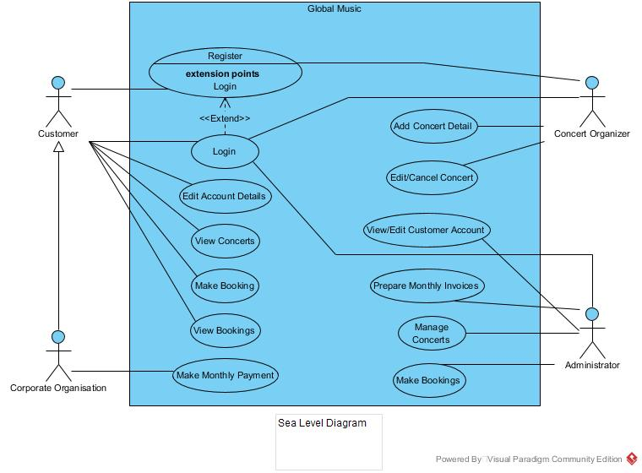

**Diagrams drawn:** Fig: Sea Level Diagram

**Codes written:** Homepage.java, Homepage.form

**Note:**

The name for this file must in the format shown below which includes the Group Number and your student number. For example, the student 123456 who worked in Group 3 would upload a file named.

**G3_123456.doc**